**DOCUMENTATION SAMPLE SHEET**

1. Development choice : Visual Studio code (sublime/PHP storm/vs code/others).

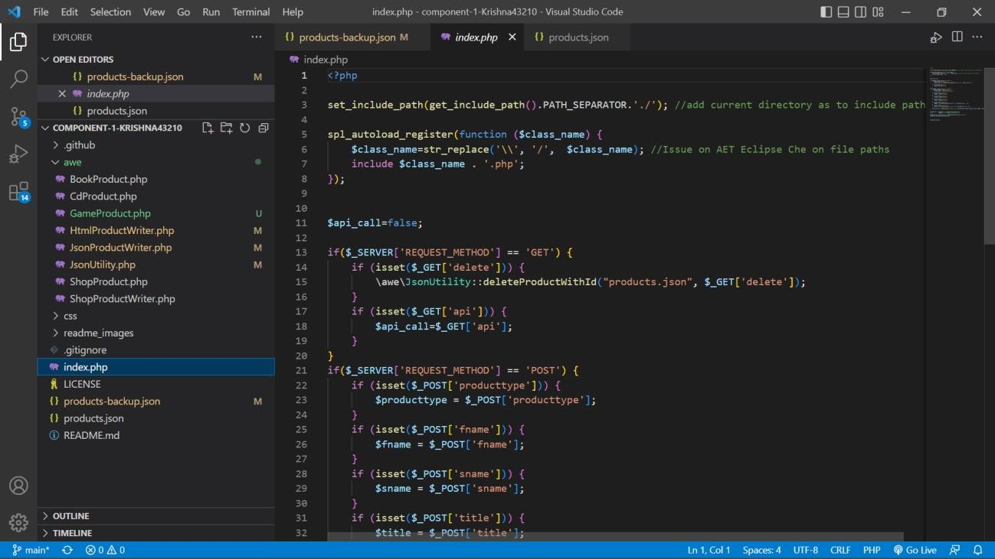

Screenshot of IDE with component 1 project code open in the IDE

1. PHP VERSION being used : 8.1.12 **(**fill with the PHP version in your system/Xampp). 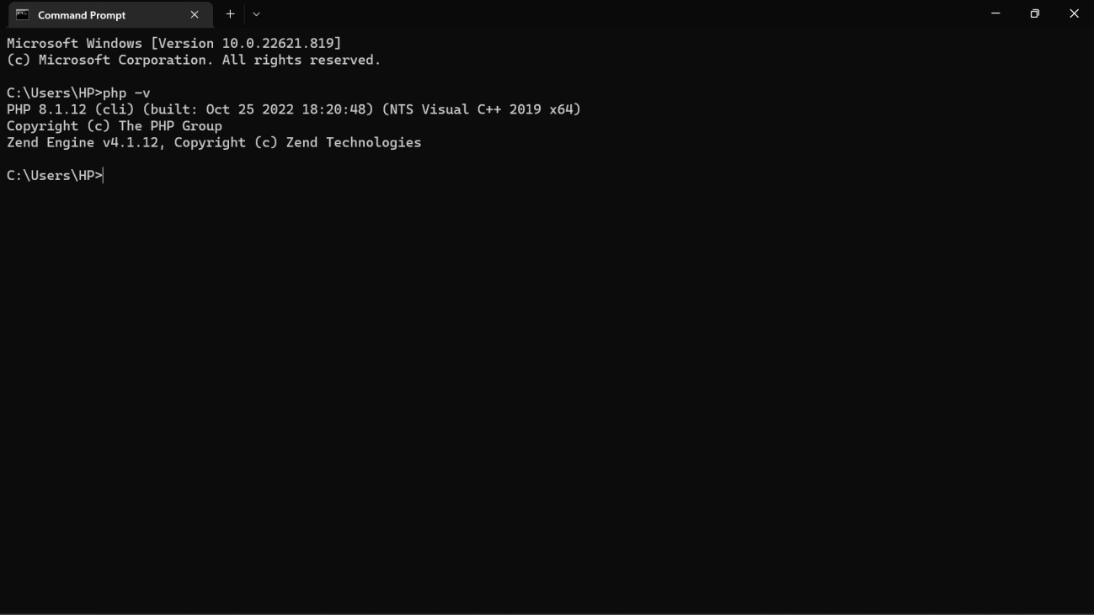 screenshot of output of php -v in command line here

1. Github account component 1 repository link : [**https://github.com/tbc-bsc-l6/component-1-**](https://github.com/tbc-bsc-l6/component-1-Krishna43210.git)

[**Krishna43210.git**](https://github.com/tbc-bsc-l6/component-1-Krishna43210.git) (your component 1 repo link here)

No screenshot needed for this

1. PHP Exercise in component 1 completed ? __yes_partial_____ (yes, no, partial)

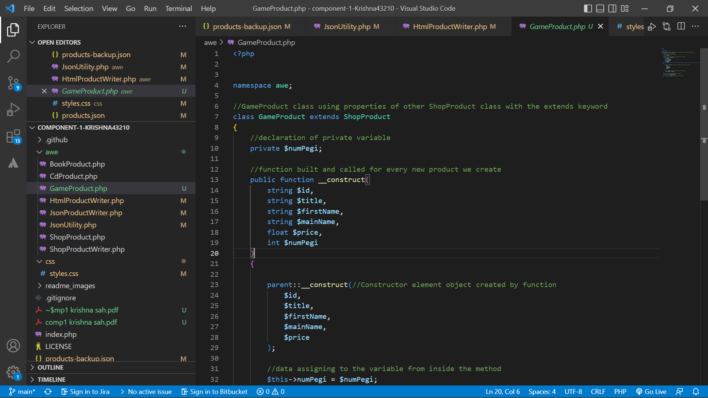

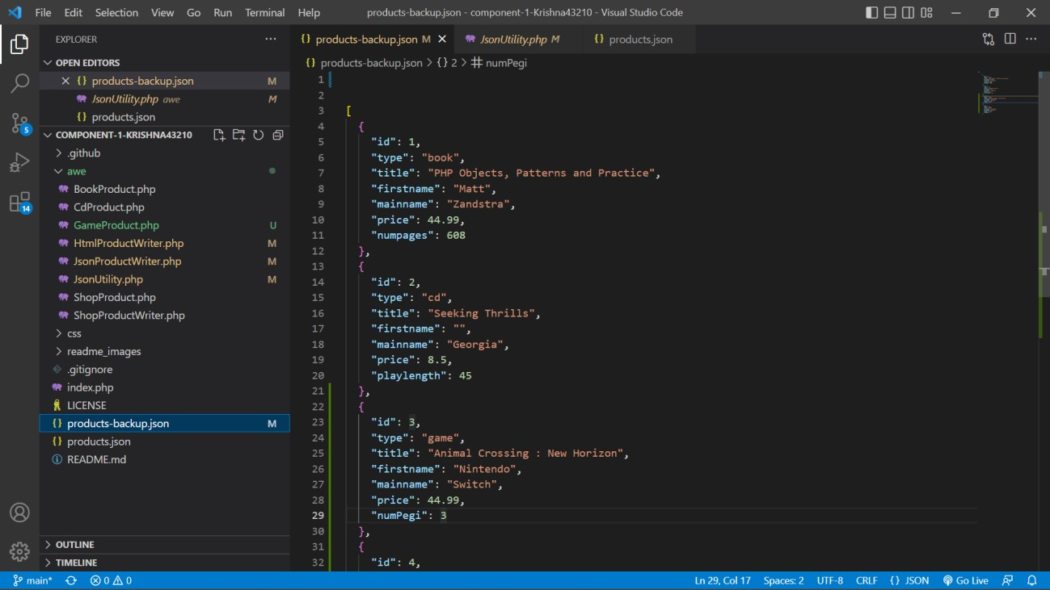

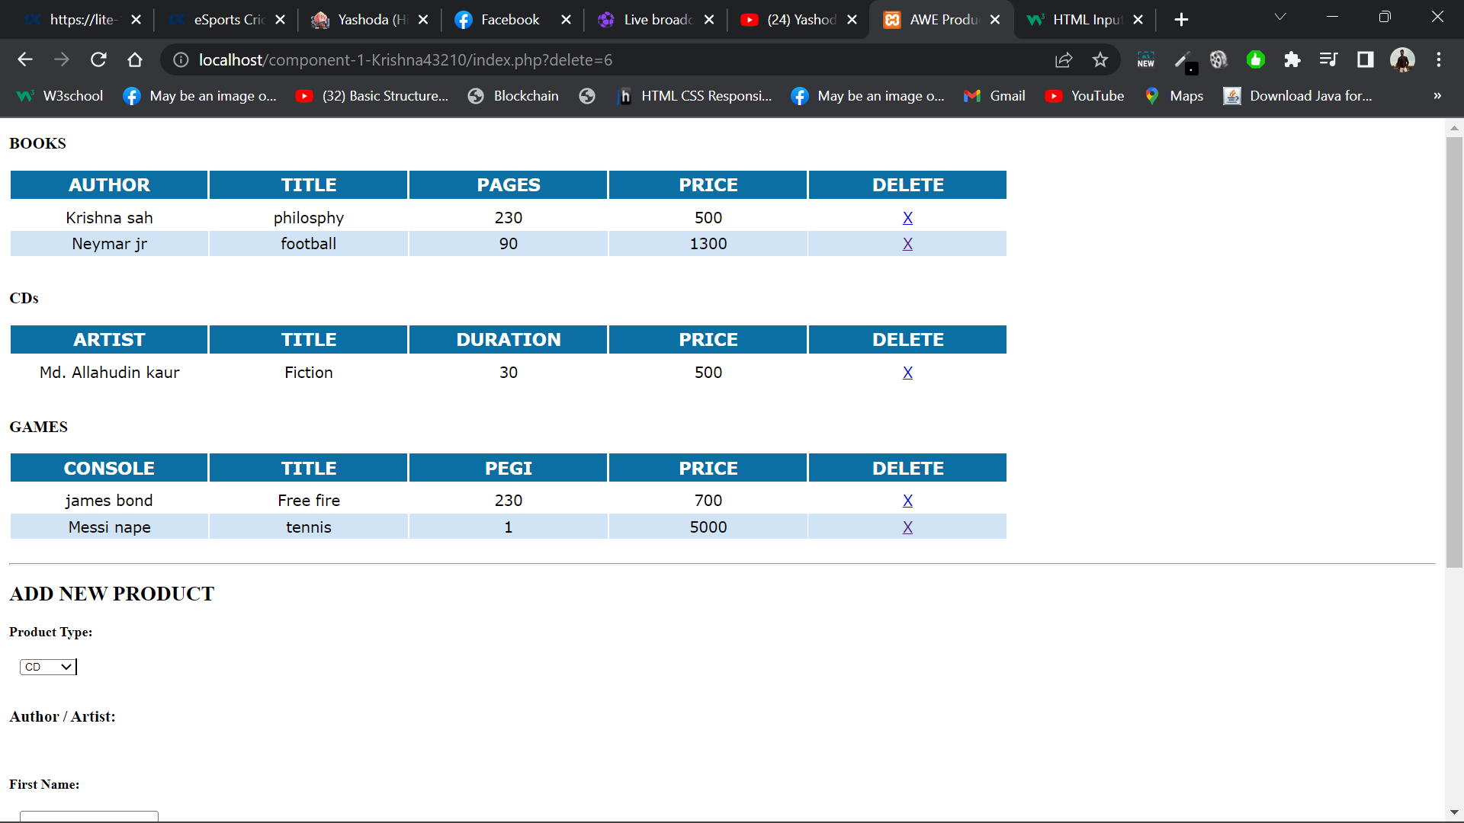

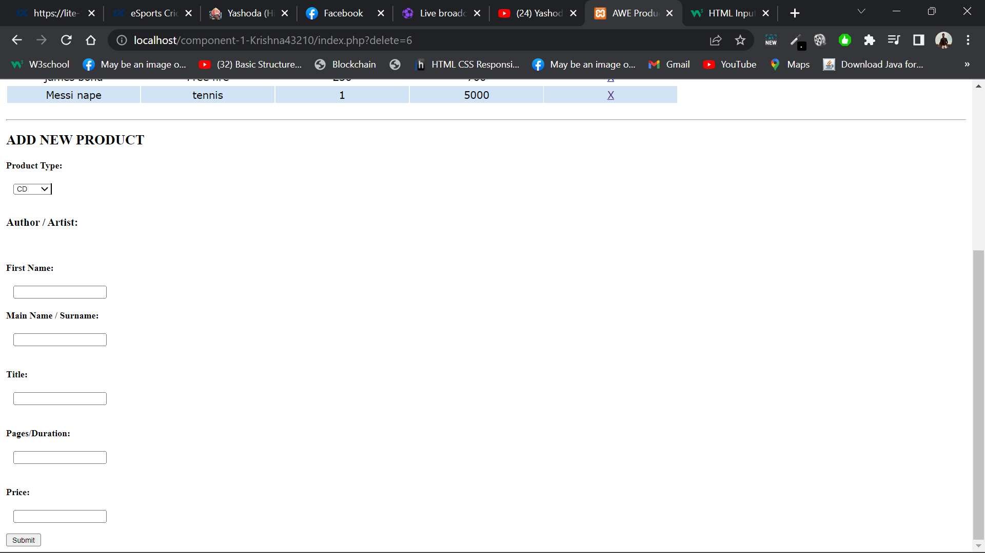

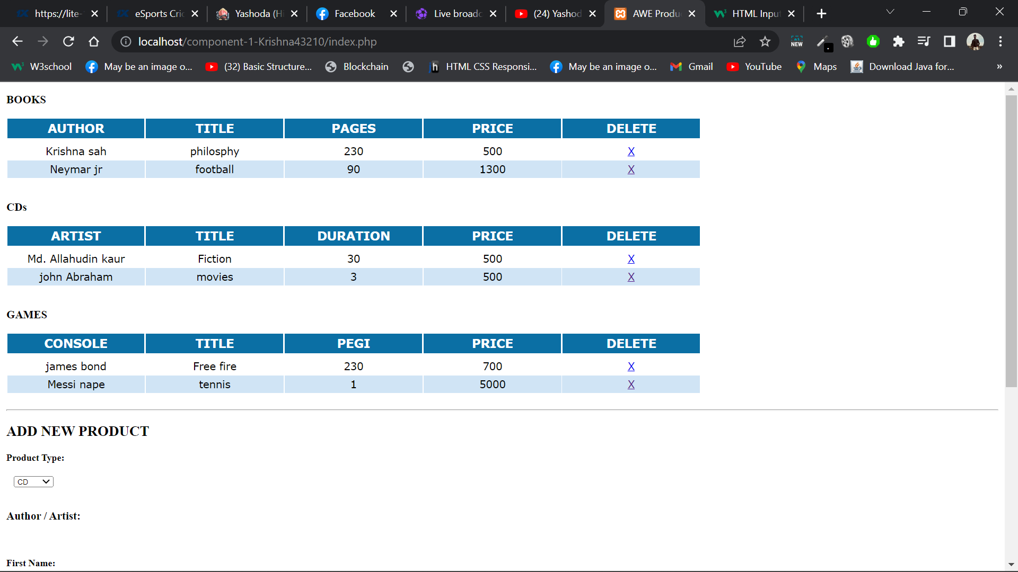

add multiple(2-4) screenshots of the frontend and source codes showing the changes you made in component 1.

Export the completed version of this document as .doc , .docx or .pdf file and push to the remote repository of your component 1.

All the best.